# Exercise 1(B) - Additional Task 4

Simulated model of the armature-controlled DC motor from the lab was used for system identification.

The input-output relationship was determined by simulating the model using SIMULINK and the data was recorded and stored in array data structure.

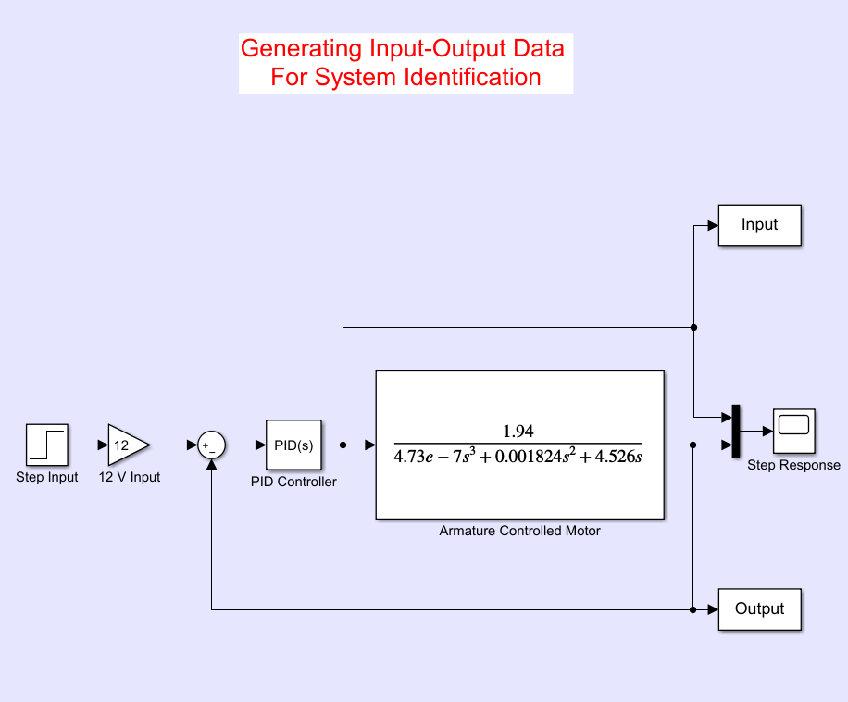

The PID controller was tuned to accurately control the armature-controlled DC motor.

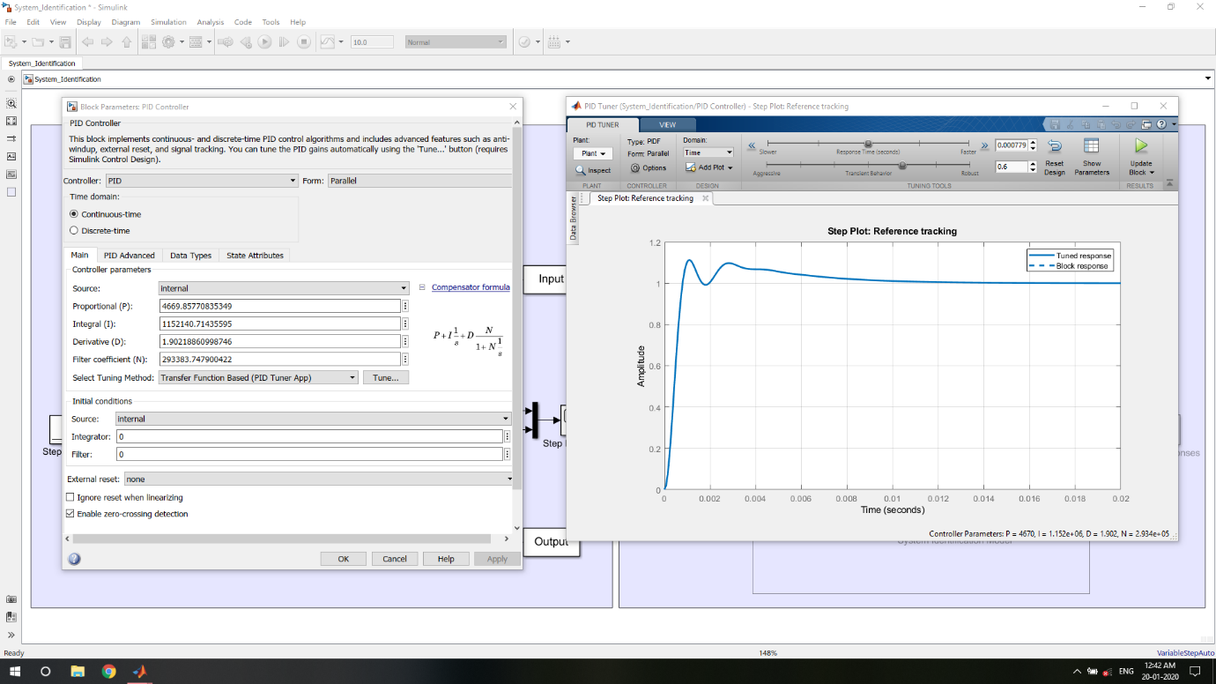

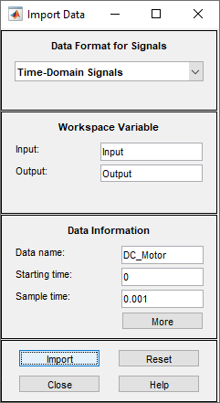The input-output dataset was imported in the System Identification Tool in MATLAB as time-domain data.

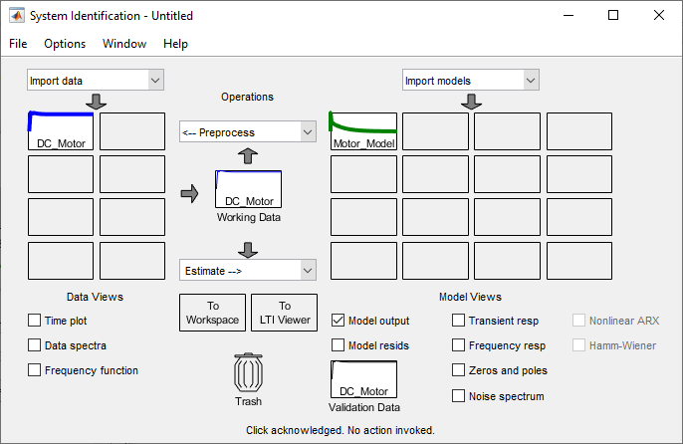

Since the mathematical model of armature-controlled DC motor consists of 3 poles and no zeros, the same was applied while performing system identification.

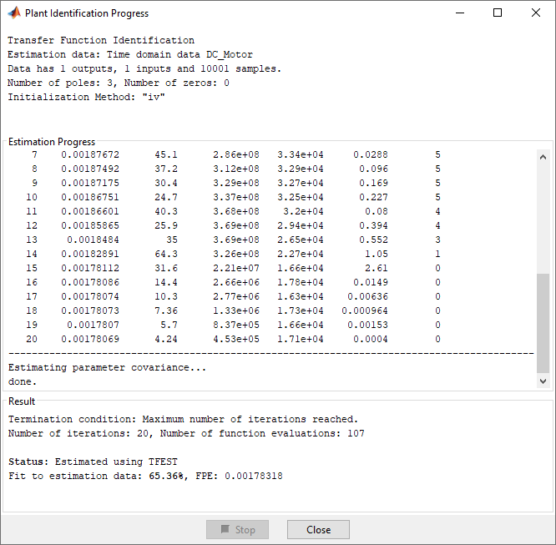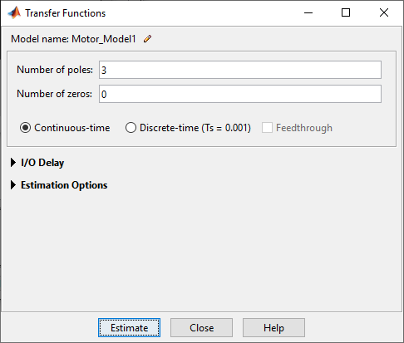

The model based on system identification made a best fit of 65.36% w.r.t. the given input-output data.

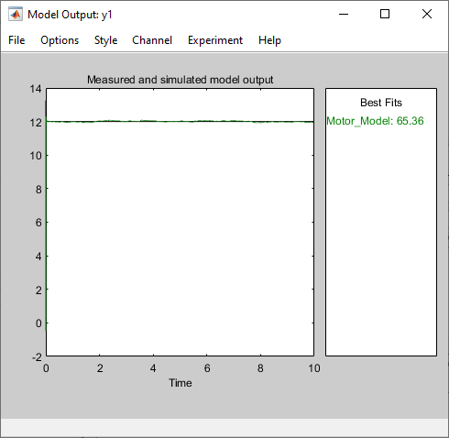

The transfer function of the model derived using system identification technique was exported to the MATLAB workspace.

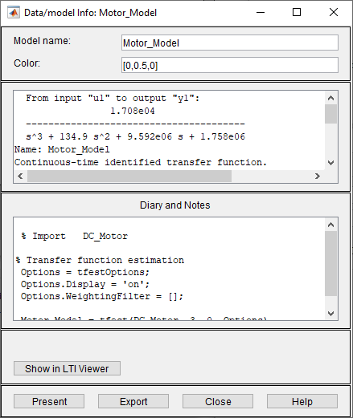

The newly obtained transfer function was applied to another transfer function block in SIMULINK alongside the original model for comparison.

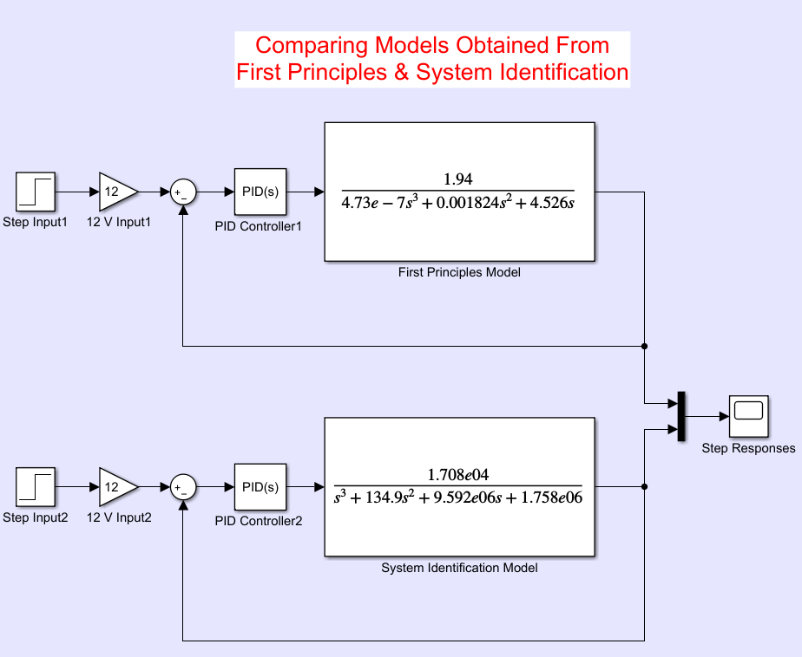

The PID controller for the system identification model was tuned to accurately control the plant.

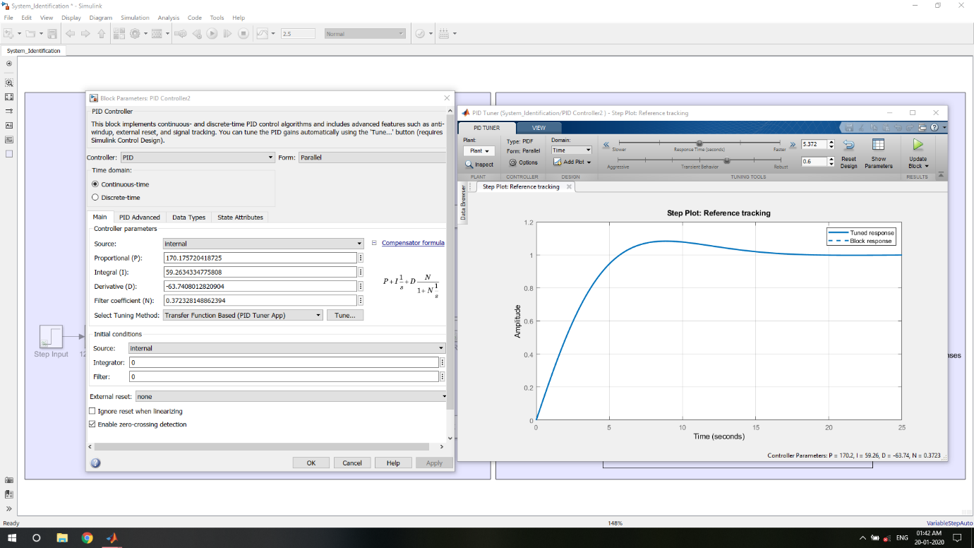

Finally, a comparison was made between the step response of the first principles model and system identification model of the armature-controlled DC motor.

